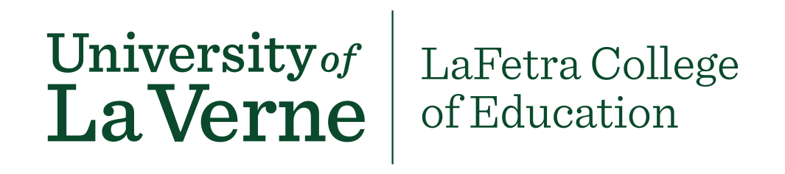

**Course Approval Process for LVE 400 Courses**

There are two opportunities for faculty to teach LVE 400.

1. **Developing a New Course**

Faculty across colleges and departments are encouraged to propose a new 1-unit course. Faculty determine the topic for the course and focus on reflection and three of the Universities Baccalaureate Learning Outcomes, Intercultural Competence, Critical Thinking and Written Communication Skills.

Or

1. **Embed the 1 unit Into an Existing Course**

Faculty can embed the unit into an existing course.

**Course Approval Process**

* Complete the GE Course Proposal Cover Sheet
* Complete the LVE 400 General Education (University Reflection attribute) Course Proposal Template
* Complete a syllabus (Please include the following content in your syllabus: Course title, course description, LVE 400 student learning outcomes (SLO’s) evidence of SLO’s, all assignments, rubrics, texts and/or readings).
* Attach these documents and the syllabus for the course and send them to Cindy Giaimo-Ballard [cgiaimo-ballard@laverne.edu](mailto:cgiaimo-ballard@laverne.edu)